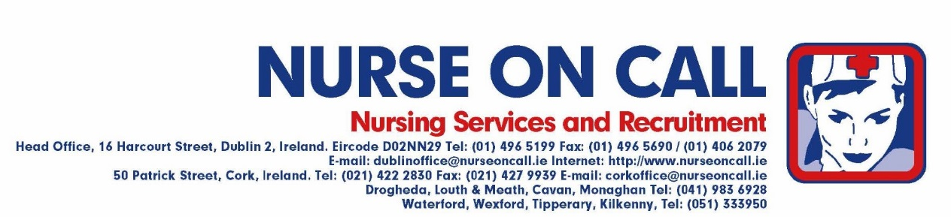

***WELCOME ALL NEW NURSE ON CALL NURSES & MIDWIVES***

Tax Credits
- Please ensure you contact your Local Tax Office before you start working to let them know you will be working with Nurse on Call. They will ask for our employers number which is 4883936A .
Putting Yourself On Call
- To make yourself available for work, please email your name, phone number and availability to
bookings@nurseoncall.ie
- On receipt of your email, we will email you back to confirm you are on call. We will then contact you as soon shifts come in (as hospital requirements change so much this can be anything from a day to a couple of weeks prior).
- We will also email you to confirm your shift once you are booked in.
- If you wish to work a Sunday you must work a Friday/Saturday or Monday with it.
- Do also keep on eye on our job emails that advertise different temporary & permanent positions coming up – you can always check out our jobs board - http://www.nurseoncall.ie/jobs-board.95.html

On Arrival to the Ward/Submitting Timesheets
- On arrival to the hospital, either report directly to the Ward or Nursing Admin as advised on booking your shift
- Ensure that you are wearing correct uniform i.e. navy trousers, white tunic top with navy piping, navy/black shoes, and of course that you at all times wear your Nurse on Call I.D. badge.
- Hair must be tidy and off your face. Jewellery and nail polish not permitted.
- Ensure that mobile phones are turned off while on duty.
- Introduce yourself to ward staff on arrival.
- Familiarise yourself with the following:
  - Paging System
  - Fire & Emergency Procedures
  - Ward Layout
  - Ward Staff will inform you what your duties will be for the shift.
  - Sign the agency signing in sheet/book before the shift and at the end of shift if applicable
- Get your timesheet signed at the end of your shift and submit to Nurse on Call before 21.30 on the following Monday. The easiest way to do this is to take a photo with your mobile phone and email it to nursesaccounts@nurseoncall.ie
- Please note that St. Vincent's University Hospital have separate timesheets and these must be submitted directly to the Nurse Bank Office on the Ground Floor in St. Vincent's.
- If you are working in St James Hospital, please ensure you sign in & out on the wards and if given a reference number for your shift to note this in the signing in book.
- Please note that Our Lady of Lourdes Drogheda have separate timesheets which can be printed out from www.nurseoncall.ie

NURSE ON CALL REFERRAL SCHEME
Nurse on Call are delighted to announce the launch of our referral scheme which is now open to all nurses and carers. If your friend/family member/colleague mentions you when registering, both of you will be entered into a monthly prize draw to win a €100.00 One-For-All Voucher or a Nurse on Call Fleece —winners will be notified in the first week of the following month.
So please do encourage all your friends to join up with us——it could be well worth it!

