

ORIENTATION HANDBOOK FOR AGENCY STAFF

1st August, 2011

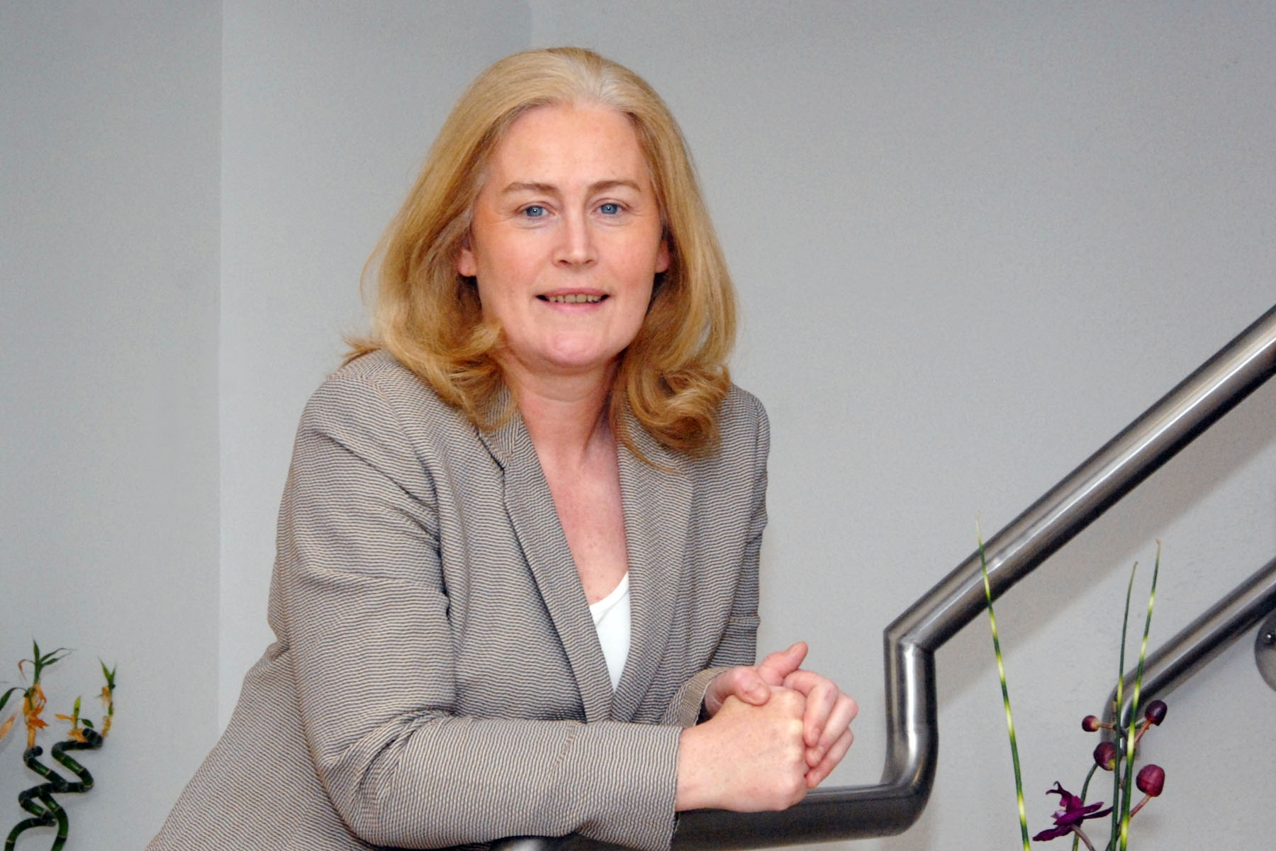

A message from Carmel

To begin with, I would like to welcome you to the Blackrock Clinic. It is our intention that you are as familiar as is possible with our hospital and the way we work. In order to help you achieve this we have put together this pocket book, which will act as a guide to assist you when you are here.

It is important that you read this guide and familiarise yourself with the essential aspects of clinical environment as well as policies and procedures prior to commencing duty. For example, certain responsibilities can be undertaken by an agency staff only in conjunction with a Blackrock Clinic employed staff. Please check with the Manager in each area for clarification.

However, as much as we try, this booklet will not be able to answer all the questions that you will have. So please ask the staff that you are working with about anything that you are unsure about.

I do hope that you will enjoy working with us here at the Clinic. We certainly appreciate you.

Yours sincerely

Carmel Mangan
Matron

Our Mission Statement

In order to understand us as an organisation we have a Mission Statement.

Our Vision

Clinical Excellence – Personal Care

Our Mission

We are an organisation in which the patient is the focus of all our thinking. We strive for long term excellence in the delivery of acute surgical, medical and diagnostic services. We aim to attract and retain the best staff in a climate of continuous quality improvement. We are committed to work as a team to provide competent, compassionate care to all those we serve.

Our Values

Compassion for the patient and their family,
Efficiency in all hospital activities,
Teamwork to provide seamless care,
Clinical excellence in all that we do,
Care and respect not only for the patient but also for each other,
Maintaining financial viability underpins our future,
Engaging professional consultants and staff,
Providing the best technology possible.

Nursing

Nurses are advised by An Bord Altranais to practice within the limits of their training, education and competence. Individual nurses allocated to Blackrock Clinic must consider their own accountability and duty of care as they practice on a day-to-day basis and make decisions regard to their scope of practice.

An Bord Altranais
2006

Doctors

Doctors assigned to duty at Blackrock Clinic should at all times adhere to “A Guide to Ethical Conduct and Behaviour” produced by the Irish Medical Council.

6th Edition
2004

Quick Tips

All four wards have a similar layout so once you become familiar with one, transferring to another ward will be easy. The nurses’ stations are situated at a halfway point in each ward. Ward receptionists are on duty during the day and this is where you will find them.

There are two utility rooms. We call one a clean utility and the other a dirty utility. The clean utility is situated down the corridor from the nurses’ station and is clearly marked. All the consumables that the unit requires are stored here. There is one dirty utility on each floor, it is shared by the two units on each floor. On the first floor it is located on PFU and on the second floor it is located on ACU.

The drug trolley is located at the nurse’ station. It is locked at all times.

A doctor writing a prescription should ensure that the prescription is legible, dated and signed. The medical officer on duty may not order over the telephone.

Medical Records – doctors must record clearly, accurately and timely in the medical record. Each entry must be dated, timed and signed.

Patient charts are stored at the nurses station.

Care planning & documentation – Each unit will contain nursing documentation in the form of a care pathway. This pathway will map out the patient journey day by day. Please consult with a member of staff who will help familiarise you with these documents.

Policy and Protocol – all policies and procedures are recorded in an electronic format. Please ask your local Manager for details.

Infection Control

We have a Clinical Nurse Specialist in Infection Control. Standard precautions must be adhered to. A comprehensive infection control manual is available on each Unit. The most important element in the control of infection is hand hygiene. Wearing gloves does not supersede hand washing. Soap and water is sufficient for the majority of procedures and hibiscrub should only be used when patients are in isolation or when participating/carrying out invasive procedures. Hand gel is widely available and should be used when entering and leaving rooms. No hand jewellery can be worn whilst at work (excluding plain wedding bands).

Confidential documentation – There is a special container in each clinical area for the disposal of confidential paper. This is clearly marked and you will see if it at the nurses’ station.

The Nurse Call System – The Nurse Call System is in place. This will be demonstrated to you when you report for duty.

Emergency/Cardiac Arrest – In the event of a cardiac arrest press the blue button on the wall panel in the patients room ensuring that the green presence button is also activated.

Alternatively, dial 3333 and state the exact location of the cardiac arrest using the patients phone.

The cardiac arrest trolley on level 1 is located outside the coronary care unit on WSU.

Paediatric Trolley is located on the Fitzgerald Ward.

The cardiac arrest trolley on level 2 is shared between the two units Florence Nightingale Unit and Abraham Colles Unit, please familarise yourself with its location when you arrive on duty.

Phlebotomy Services

- By In-House Phlebotomy:

Phlebotomy | Mon – Thurs 7.00 am – 7.00 pm  Fri 7.00 am – 3.00 pm | Sat 7.00 am – 10.30 am (routine)  Sun 8.30 am – 11.00 am (routine) 1.00 pm – 3.00 pm (admission)
Cannulation | Mon – Thurs 7.00 am – 5.00 pm  Fri 7.00 am – 3.00 pm | No weekend or public holiday service

- By Out-Patient Phlebotomy: Admissions after Friday 3.00 pm can be referred here for phlebotomy only.
- For all other hours, cannulation & blood taking to be done by RMO.

RMO Phlebotomy Trolleys

- Available on all 4 main wards.
- Please keep it clean & safe, disposing of all sharps into the sharp bins and wiping up any blood spills. If supply is low, phlebotomy stock may be found in Colles (ACU) ward’s Clean Utility room.
- New sharp bins & Clinical waste (yellow bag) are located in Dirty Utility Room, found between wards on each floor.
Fire Safety

Fire escape routes, fire extinguishers and break glass point locations are displayed on a safety notice on each floor. If you discover a fire:

- Alert other occupants.
- Break glass in the nearest fire call point.
- Activate the fire alarm by dialing 4444 and state the exact location of the fire.

We have regular fire drills here at the hospital. Every Friday at 8.45 am a fire alarm test is carried out.

How to Operate the Bleep/Paging System

Staff who work in various locations throughout the hospital will carry a bleep so that you can communicate with them when you need to. To activate the paging system, follow these steps: -

Dial 51 then press 1 to page, followed by the number you wish to page and lastly enter the extension you wish that person to phone you at. Sounds confusing but it is really quite easy when you go to do it!

For example Matron carries bleep number 04, therefore to contact her you would dial 51 then press 1, followed by 04 then enter the extension you are currently at. You can also speak directly through the pager. The window to speak lasts several seconds therefore you must keep your message brief further explanations can be given when the person contacts you.

Do not discuss confidential information over the paging system, this includes patients’ names.

The paging system has a voice operator that assists you as you are paging so do not worry about trying to remember how the system works when you dial 51 you will hear a voice that will guide you. A number of people carry bleeps and the information is available at the nurse station.

Contacting Consultants – If you wish to contact a Consultant please liaise with the Clinical Nurse Manager or Blackrock Clinic staff nurse. The telephone numbers of the consultants are listed at each station. Do not give consultants contact details to anyone.
Guide to Our Clinical Areas

William Stokes Unit – generally referred to as WSU or Stokes for short. It is located on the first floor and is where you will find our cardiac patients. It has 32 beds in total they are numbered from 204 – 233. The majority of the beds are single private rooms with the exception of 211/212/214 & 215, which is a four-bedded unit. Number 227 & 228 is our two-bedded in the coronary care unit.

- 4379 / 4380

Patrick Fitzgerald Unit – generally referred to as PFU or Fitzgerald for short. It is also located on the first floor and the patient mix is surgical, medical, paediatric and ENT. It has 24 beds in total they are numbered from 104 – 131. The numbers 121/122/123 & 124 is a four-bedded unit, 107 & 108 is a two bedded room.

- 4351 / 4352

Florence Nightingale Unit – generally referred to as FNU or Nightingale for short. It is located on the second floor and the patient mix is oncology, neurosurgical/spinal. The Unit has 21 beds in total they are numbered from 304 – 331. Attached to this Unit is a 6-bay oncology day unit. The numbers 321/322/323 and 324 refers to the four-bedded room. 307 and 308 are the double rooms; the remaining numbers are single rooms.

The Oncology day unit is open Monday – Friday.

- 4355 / 4356
- 4226 (Oncology Day Unit)

Abraham Colles Unit – generally referred to as ACU or Colles for short. It is located on the second floor and is where you will find our orthopaedic patients.

There are 30 beds numbered from 330 – 433. The four-bedded wards are 411 / 412 / 414 and 415, the two-bedded ward are number 427 and 428. The remaining rooms are single.

- 4324 / 4325

Intensive Care – The ICU is located on the lower ground floor adjacent to the recovery room area. It has six beds and two isolation cubicles.

- 4353

The Day Unit – Is located on the lower ground floor. You will see that it is divided into two main working areas, admission / reception and the clinical area. The Day Unit accommodates the endoscopy room, a procedure room where minor procedures are carried out and a room for wound dressings.

- 4326 / 4327

Theatre – We have a total of five operating suites and five recovery bays. Theatre is located on the lower ground floor. This area is a restricted zone and can only be accessed wearing theatre scrubs, which are provided in the theatre changing rooms.

- 3031 / 3024

Angiography Day Unit – The Cardiac Angiography suite has a dedicated 6 bedded area attached. Patients recover from their angiography procedures in this area prior to their discharge. This area is closed overnight.

- 4278 / 3020

Excimer Laser – is the area where we carry out eye laser procedures. It’s located on the lower ground floor. This area is open Monday to Friday, it is closed overnight.

- 4337 / 4338

Agency staff Checklist

Nursing Staff Checklist:

The following to be checked immediately when reporting on duty: -

Report to the Manager or Person in charge

Sign for confirmation of duty in agency log
Location of the drug trolley
Location of crash trolley & Cardiac Arrest
activation
Location of the emergency exits & Fire Policy
Sign “orientation to ward” document

Doctors Checklist:

The following to be checked immediately when the doctor is reporting on duty:-

Report to the Matron or Senior Nurse in charge
Sign for confirmation of duty
Location of the emergency exits & Fire Policy

How to get to Blackrock Clinic

The Clinic is situated on the Rock Road, Blackrock, Co. Dublin, and is easily accessible by public or private transport.

Buses 7 and 7a depart from O’Connell Street and stop directly opposite the Clinic entrance. Buses also depart from Dalkey, Loughlinstown and Sallynoggin and service the Dun Laoghaire district not far from the Clinic.
For Bus information, phone 01 836 6111.

The DART train service stop at Booterstown and Blackrock Station, both short walking distances from the Clinic. For DART information, phone 01 873 4222.

There are extensive bicycle paths along the Rock Road. Bicycle parking is available on the Clinic grounds.

There is limited car parking available at the Clinic due to high demand. An agency nurse who has parked his/her car on the Clinic grounds must enter name, car registration number and name of ward on which he/she is working, into the visitors parking book at Reception.

